project management plan

for the

FaShion store website

20/10/2016



Team Number: 12

Team Member: Salma Mohamed Yassin - 133722

# SECTION 5. MANAGEment PROCESS

**5.2 Work Planning**

**3.2.1 Work Activities (WBS)**

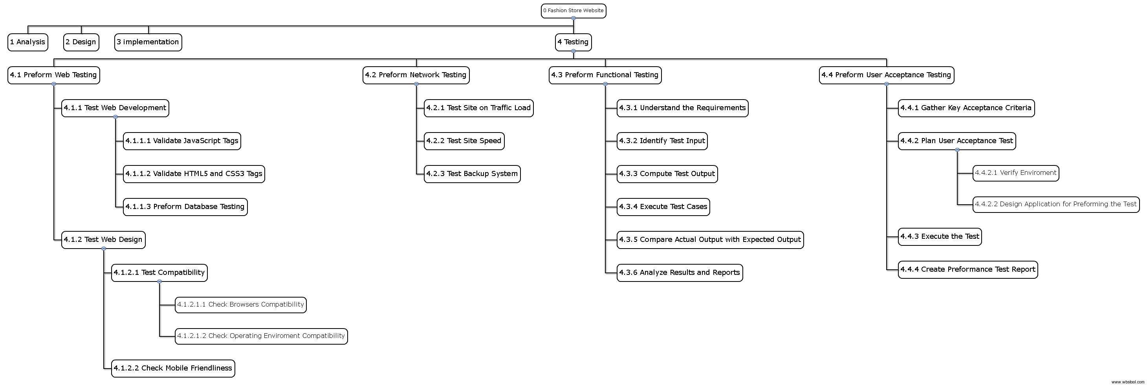

### 

### 5.2.2 Schedule Allocation

|  |  |  |  |
| --- | --- | --- | --- |
| Activity | Description | Predecessor | Duration (Days) |
| A | Preform Database Testing | ___ | 3 |
| B | Validate JavaScript Tags | ___ | 5 |
| C | Validate HTML5 & CSS3 | ___ | 4 |
| D | Test Compatibility | A, B | 2 |
| E | Test Mobile Friendliness | A, B | 2 |
| F | Test Site on Traffic Load | ___ | 2 |
| G | Test Site Speed | F | 1 |
| H | Test Backup System | ___ | 3 |
| I | Understand the Functions Requirements | ___ | 4 |
| J | Identify Test Input | I | 2 |
| K | Compute Test Output | I | 2 |
| L | Execute Test Cases | J, K | 7 |
| M | Compare Actual Output with Expected Output | K, L | 4 |
| N | Analyze Results | M | 3 |
| O | Gather Key Acceptance Criteria | ___ | 2 |
| P | Plan User Acceptance Test | O | 3 |
| Q | Execute User Acceptance Test | P | 4 |
| R | Create Performance Test Reports | Q | 4 |

**5.2.3 Resource Allocation**

* Hardware needed: Multisim, ADSL and a PC or a Laptop
* Software needed: HTML5, CSS3, JavaScript, JQuery, and an Operating System
* 4 Quality assurance are needed to test out those two main functions of the system; To display the site’s products through different categories of the site and for the admin to track the sold items to insure their availability in the inventory
* 5000$ for each Quality assurance needed for testing the Website
* A meeting place for the testing team to meet and work together

## 5.4 RISK MANAGEMENT

|  |  |  |  |  |
| --- | --- | --- | --- | --- |
| Risk | Description | Probability | Loss | Exposure |
| 1. Requirements are not clearly defined | The User Requirements can possible be written in a vague way that the implementation and quality assurance teams will not understand clearly making their implantation and testing for the functionalities of the site not very well constructed | 35% |  |  |
| 1. The site broke after an upgrade | The more complicated a system, the more corners there are where things can break. There might be something that isn't quite right in the site. And putting a fix in one error might ends up breaking something else. | 15% |  |  |
| 1. Making the user acceptance test (Usability test) is too difficult for the users to complete | The testing team can make Usability test very hard for the users to understand and to complete as the users like tests which involves choice making and not writing essay answers that will surly affect the usability of the site | 20% |  |  |
| 1. No real performance test planning | The Testers of the site can have a performance test plan but not follow it because they might think that they just have to identify test cases and test them out through the system but the performance test plan is more than just executing test cases, it identify the methodology and time span the testers should follow to reach the targeted tests of the plan | 10% |  |  |
|  |  |  |  |  |

**Contingency plan:**

* No real performance test planning:

1. The performance test plan have to document the performance test targets so it is known when they have been met or not met
2. The performance test plan must allow sufficient time for testers to test all test cases
3. A strict methodical approach to performance testing should be enforced in the performance test plan
4. The performance test plan must allow for defects in the testing process and cater for additional test execution cycles to cover for this

|  |  |  |  |  |  |  |
| --- | --- | --- | --- | --- | --- | --- |
| Activity | Optimistic (a) | Most Likely (m) | Pessimistic (b) | Expected Time (Te) | Standard Deviation (s) | Description |
|  |  |  |  |  |  |  |
|  |  |  |  |  |  |  |

**Risk Planning:**